## INTRODUCTION

GTFS (General Transit Feed Specification) is a standardized format for public transportation schedules and geographic data. It allows transit agencies to publish their data in a format that applications like Google Maps, transit apps, and trip planners can use to provide real-time route, schedule, and fare information.

The data that we sent in JSON file was generated via GTFS data. So you need to use that JSON data(maybe you need to convert it into SQL) in order to train AI model.

Here is the raw GTFS file - <https://drive.google.com/file/d/1R3TzCbDFHKh36zQfM1VwLkiyLbIjknS2/view?usp=sharing>

But you can not use this GTFS file as it does not have all the details, like vessels and prices. That’s why i generated JSON files from this GTFS zip file so that you can use JSON files.

GTFS_data_v1.json has less data.

GTFS_data_v2_full.json has full data.

So it’s up to you, which data you want to use. And you need to tell us the file you used to train AI model.

## RECENTLY SHARED FILES (on 06th March 2025)

### GTFS appear dates_v1_06032025.json -

This data appears to represent ferry schedules between different locations. It includes information on when ferry routes are available between specific origins and destinations. Here's a breakdown of the structure:

1. **Origin and Destination** Each object contains two key properties:
   * origin_name: The starting point of the ferry (e.g., "HYD___Ydra").
   * destination_name: The endpoint of the ferry (e.g., "POR___Poros").
2. **Date Ranges** Each object also contains a dateRanges array, which specifies when the ferry service is available between the given origin and destination. Each dateRanges entry contains:
   * startDate: The first day when the ferry is operational.
   * endDate: The last day when the ferry is operational within that period.
   * appearDate: The date when this schedule was published or became visible for booking.

### GTFS calendar_v1_06032025.json [OPTIONAL DATA] -

This data represents a **calendar of ferry routes**, showing on which dates trips are available between specific locations.

Dates are already there under GTFS data_v3_06032025.json file for each trip. So you can use it. This file has unique dates extracted for all routes. that’s it!

### **Breakdown of the Structure**

* The **key** ("ANC___DRZ___Ancona___Durres") represents a ferry route:
  + ANC: **Ancona** (origin port)
  + DRZ: **Durres** (destination port)
  + "Ancona___Durres": Human-readable format of the route
* The **value** (array of dates) lists the exact dates when ferries are operating on this route.

### **What This Data Represents**

* **Schedule Information:** It tells you **when ferries will be running** between Ancona and Durres.
* **Predefined Availability:** This is a **pre-set calendar** indicating available departures.
* **No Time Details:** The data only contains dates, not specific departure times.

### GTFS data_v3_06032025.json -

The data format is almost identical to **GTFS_data_v1.json**, with the only difference being the accommodation prices. In this version, I've included both **indicative prices** and **accommodation prices** for all vessels across all trips.

## 

## FERRIES IN GREECE (https://www.ferriesingreece.com/)

**FerriesinGreece.com** is an online platform for booking ferry tickets to Greece and the Greek islands. It has been operating since 2008 and provides a seamless booking experience for travelers looking to explore Greece by ferry.

The main purpose of **FerriesinGreece.com** is to provide a **convenient and reliable** online booking system for ferry tickets to **Greece and the Greek islands**. It aims to simplify the process of planning and booking ferry trips while ensuring **excellent customer support** before, during, and after the journey.

### **Key Features of FerriesinGreece.com:**

✅ **Easy Online Booking System** – Users can search for ferry schedules, check availability, view vessel photos, and book tickets through a secure platform.  
✅ **Wide Coverage** – The website collaborates with most Greek ferry companies, allowing users to book tickets for almost all Greek islands. It also offers ferry routes connecting Greece with **Italy and Turkey**.  
✅ **Expert Assistance** – Beyond ticket sales, the company provides personalized support during and after the booking process. Their trained staff assists with any travel-related inquiries, ensuring a smooth ferry experience.  
✅ **Strong Industry Presence** – Handling over **100,000 passengers per year**, FerriesinGreece.com has built a solid reputation in Greek tourism.

In short, it’s a **one-stop solution** for booking Greek ferries, offering a user-friendly system, extensive route options, and excellent customer support. 🚢✨

**Booking Process:-**

1. Search Widget - To search trips for specific quote

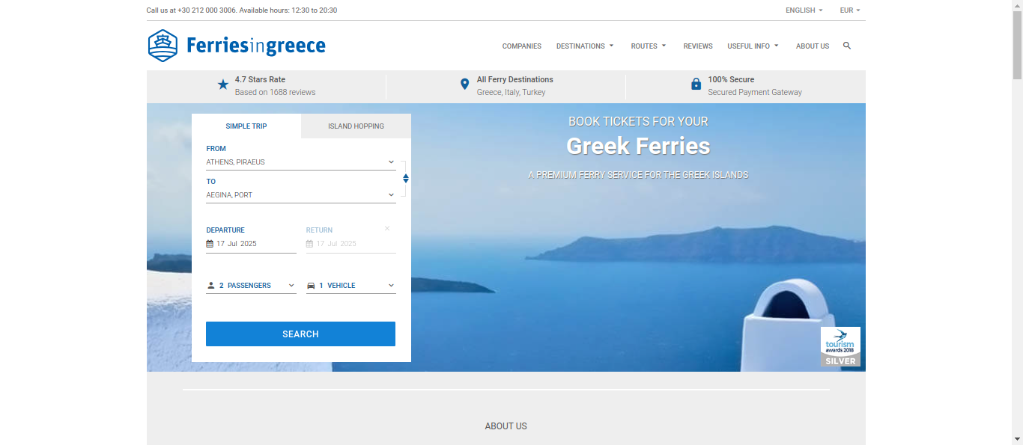

Select Origin, Destination, Departure Date and Passengers and Vehicles.

Same way User can also search trips for island hopping.

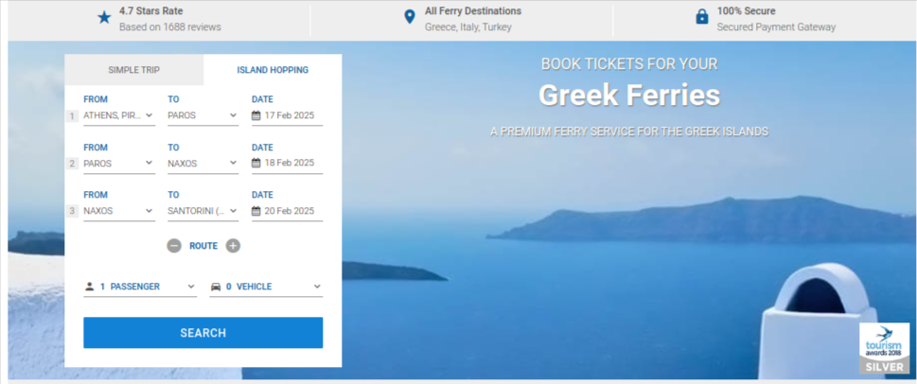

1. Seach Result - List of trips available for specific search criteria.

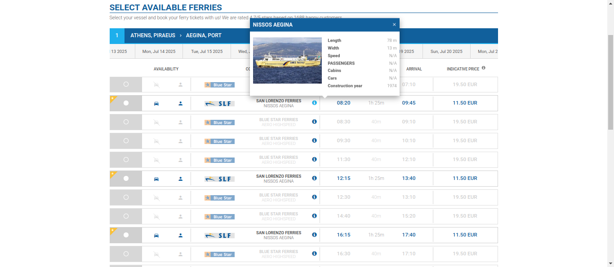

As you can see in above print screen, it shows available trips with company, timing and price information.

1. Pricing page - Where User have to add information about passengers, vehicles etc and check for prices and availability.

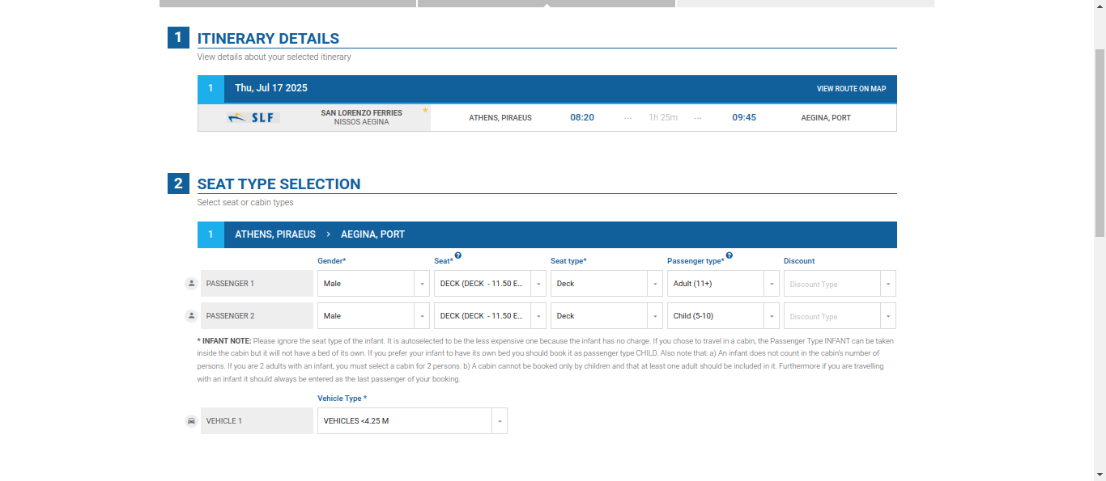

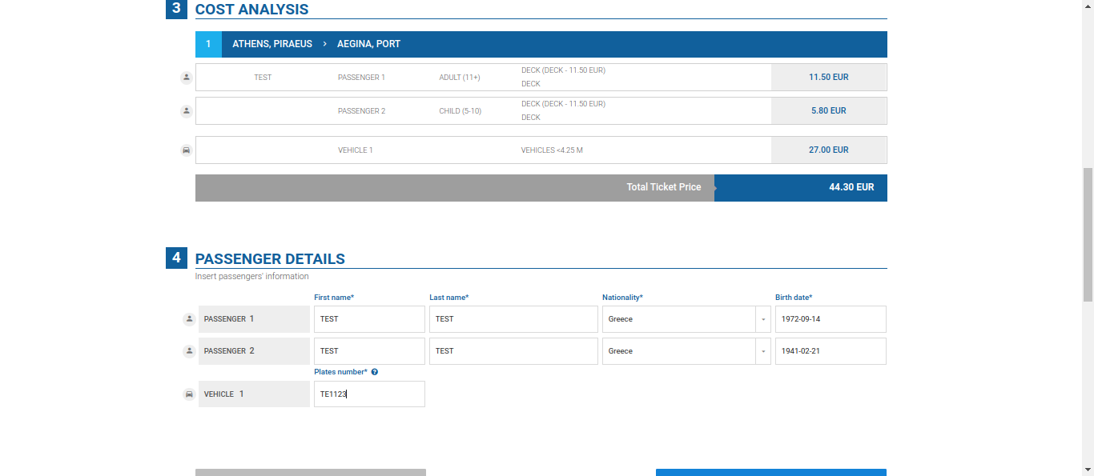

1. Payment Page - Add Leader details & Choose service plan & Make payment

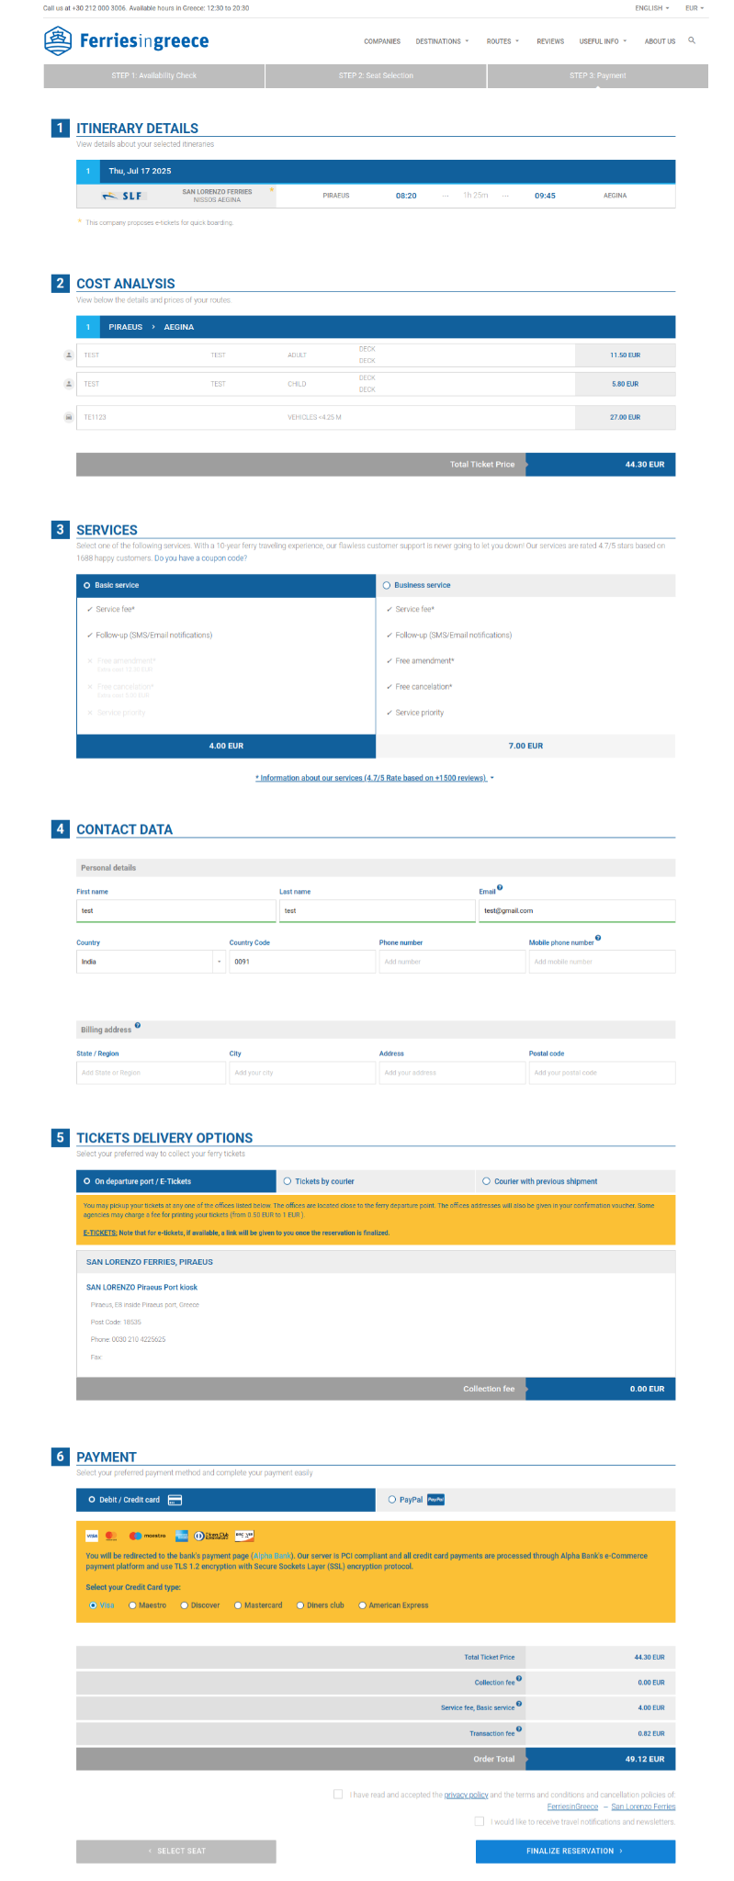

## EXPLANATION OF PROPERTIES OF GTFS JSON FILE

### **Top-Level Fields**

#### **route_id**

* A unique identifier for an itinerary. This does **not** represent a specific route or trip but rather an entire itinerary covering multiple stops.

#### **company**

* The ferry company operating the route, e.g., "AEGEAN SEA LINES".

#### **company_code**

* A short code representing the ferry company, e.g., "AEG".

### **Port Information**

#### **origin_port**

* The starting port of the journey (e.g., "MLO" for Milos).

#### **origin_port_code**

* The full name of the origin port (e.g., "Milos").

#### **destination_port**

* The port where the ferry arrives (e.g., "KMS" for Kimolos).

#### **destination_port_code**

* The full name of the destination port (e.g., "Kimolos").

### **Time and Duration**

#### **departure_time**

* The scheduled departure time from the origin port in **HH:MM** format (e.g., "13:00").

#### **arrival_time**

* The scheduled arrival time at the destination port in **HH:MM** format (e.g., "13:55").

#### **origin_port_stop**

* The stop number of the origin port in the itinerary sequence.
  + Example: 1 means the first stop, 2 means the second stop.

#### **destination_port_stop**

* The stop number of the destination port in the itinerary sequence.
  + Example: 5 means the fifth stop in the itinerary.

#### **departure_offset**

* A time offset (in hours) from a reference point (e.g., 2 means the departure is considered 2 hours from a base reference).

#### **arrival_offset**

* A time offset (in hours) from a reference point (e.g., 2 means the arrival is considered 2 hours from a base reference).

#### **duration**

* The total duration of travel from **origin to destination**, measured in **minutes** (e.g., 55 means 55 minutes).

### **Date and Vessel Information**

#### **dates_and_vessels**

* A mapping of **specific dates** to the ferry vessel operating on that date.

Example:  
json  
{

"2025-03-16": "53___ANEMOS",

"2025-03-23": "53___ANEMOS"

}

* + This means that on **March 16, 2025**, and **March 23, 2025**, the vessel "53___ANEMOS" will operate this route. Where 53 is vessel code and ANEMOS is vessel name.

#### **vessels_and_indicative_prices**

* A mapping of ferry vessels to **ticket prices (in cents or minor currency units)**.

Example:  
json  
{

"53___ANEMOS": 1100

}

* + This means that the vessel "53___ANEMOS" charges **€11.00** (prices are in cents) for this route.

#### **vessels_and_accommodation_prices**

* A mapping of ferry vessels to **ticket prices (in cents or minor currency units)**.

Example:  
json  
"vessels_and_accommodation_prices": {

"53___ANEMOS": {

"DECK___DECK": 1300,

"IN01___INFANT 0-1": 0,

"EC___Economy numbered seat": 2000

}

}

* + This means that the vessel "53___ANEMOS" for this route.
  + "DECK___DECK": 1300 means for DECK accommodation price is **€13.00**

### **Understanding an Example Entry**

#### **Example:**

json

{

"route_id": "108815278",

"company": "AEGEAN SEA LINES",

"company_code": "AEG",

"origin_port": "MLO",

"origin_port_code": "Milos",

"destination_port": "KMS",

"destination_port_code": "Kimolos",

"departure_time": "13:00",

"arrival_time": "13:55",

"origin_port_stop": 1,

"destination_port_stop": 2,

"departure_offset": 2,

"arrival_offset": 2,

"duration": 55,

"dates_and_vessels": {

"2025-03-16": "53___ANEMOS"

},

"vessels_and_prices": {

"53___ANEMOS": 1100

}

}

#### **Breakdown:**

* This itinerary belongs to **route_id 108815278**.
* It is operated by **AEGEAN SEA LINES (AEG)**.
* The ferry **departs from Milos (MLO)** at **13:00** and **arrives in Kimolos (KMS)** at **13:55**.
* The **duration** of this trip is **55 minutes**.
* The ferry makes **its first stop in Milos (stop 1)** and then **its second stop in Kimolos (stop 2)**.
* The same ferry, "53___ANEMOS", operates this route on **March 16, 2025**.
* The price for this ferry is **€11.00**.

## SAMPLE QUESTIONS WE WILL ASK TO BOT

If you use this data to train an AI chatbot for ferry booking, the chatbot should be able to answer various questions about ferry trips. Here are some examples of the types of questions users might ask, along with the expected responses based on the given data:

### **1. General Search Questions**

* **"What ferries are available from Milos to Piraeus?"***The chatbot should list the trips from Milos (MLO) to Piraeus (PIR), showing details like departure time, duration, vessel, and price.*
* **"Is there a ferry from Kimolos to Serifos on March 23, 2025?"***The chatbot should check if there is a ferry on that date and provide details such as departure time, arrival time, duration, and price.*
* **"Which ferry operates between Sifnos and Serifos?"***The chatbot should show the ferry details for the Sifnos (SIF) to Serifos (SER) route.*

### **2. Price and Duration Queries**

* **"How much is a ticket from Milos to Serifos?"***The chatbot should check the price for that route (e.g., 7200 in the given data).*
* **"What is the fastest ferry from Milos to Piraeus?"***The chatbot should compare all available routes and find the shortest duration.*
* **"How long does it take to travel from Kimolos to Sifnos?"***The chatbot should return the duration (e.g., 50 minutes).*

### **3. Date-Specific Queries**

* **"Is there a ferry from Milos to Kimolos on April 6, 2025?"***The chatbot should check if this route operates on the given date and return the relevant trip details.*
* **"Which ferries are available on May 4, 2025?"***The chatbot should list all routes operating on that date with their details.*

### **4. Multi-Segment Queries (Indirect Trips)**

* **"Can I travel from Kimolos to Piraeus with a stop in Serifos?"***The chatbot should check if a combination of routes allows travel through Serifos.*
* **"What are my options for traveling from Milos to Piraeus with a stop in Sifnos?"***The chatbot should identify indirect trips and display options.*

### **5. Vessel Queries**

* **"Which vessel operates from Milos to Sifnos?"***The chatbot should return "53___ANEMOS".*
* **"What is the vessel for the route from Serifos to Piraeus?"***The chatbot should check and return "53___ANEMOS".*

### **6. Schedule and Timing Queries**

* **"What time does the ferry from Milos to Sifnos depart?"***The chatbot should return "13:00".*
* **"When does the ferry arrive in Piraeus from Milos?"***The chatbot should return "20:15".*
* **"What are the departure times for ferries from Kimolos?"***The chatbot should return all departure times for ferries from Kimolos.*

### **7. Cheapest and Most Expensive Queries**

* **"What is the cheapest ferry from Milos to Piraeus?"***The chatbot should compare prices and return the cheapest option.*
* **"What is the most expensive ferry route available?"***The chatbot should analyze the price data and return the highest-priced route.*

## IF ANY DOUBTS, WRITE BELOW!

*Request for access to write this document.*

*Write your doubts here*